Name : Sakthi Manoj R Reg No : 192324236
PROGRAM 9
Create Empty Plots with Specified Axis Limits
Aim:
To create empty plots with specified axis limits.
Procedure:
Step 1: Open RStudio or R console on your computer.
Step 2: Remove the variable named c from the workspace using the remove function.
Step 3: Use the plot function to create an empty graph by setting the type as n.
Step 4: Define the range of the x-axis and y-axis using xlim and ylim.
Step 5: Label the x-axis and y-axis with appropriate names.
Step 6: Run the program to display an empty plotting area ready for adding points or lines later.
OutPut:
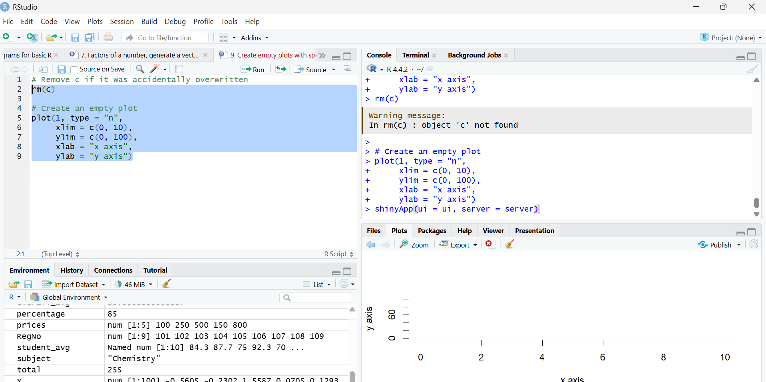
Result:
Hence the output is verified successfully.

